# Final Report

**Group Number**: C

**Number of all members**: 4

|  |
| --- |
| Workload |
| Choi Wai Kit: 25%  YEUNG Ip Chung: 25%  LEUNG Chi Sum: 25%  ZHENG Yao Cheng: 25% |

# Abstract

Hong Kong Cube Shop is one of the largest chain cube shops in Hong Kong. In order to increase the competitiveness, our project team have interviewed various stakeholder such as Managing Director, Human Resources Manager, Information Technology Officer and so on. Our project team elicits requirements of project from them and will develop an online system for HKCS to perform both management and leasing of showcases. The system may have some advanced features to facilitate activities of daily shop management, for example, printing electronic receipt and providing an online platform for tenants to monitor sales record .

Contents

System Analysis and Design Report 0

Abstract 1

Introduction 3

Problem Findings 4

Requirement of the proposed system 6

Design of the proposed system 9

System Architecture 9

System Analysis and design 10

Project Schedule 35

Conclusion 36

Project Log 37

# Introduction

Hong Kong Cube Shop is going to expand their business next year. In order to handle the coming larger business. HKCS needs a computer system for management. At present, HKCS employs staff for leasing showcases and selling tenant's items manually so that the staff have lots of works to do. As the result the efficiency and effectiveness are low. The new system will increase the efficiency and effectiveness significantly.

Regarding the daily operation in shop. The duty of the clerk is to suggest the most suitable showcase to tenants and sell items of showcases to customers. The tenant who wants to rent showcase need to sign a contract and pay the total rental cost before the rental period commences. On the other hand, about the sales of items, staff need to record the sales information of the unit price, the quantity, the name of the item and then print out a copy of receipt to customer. Obviously, it will take lots of time. The stock-in procedure is also time-consuming because the clerk needs to input the data one by one to the computer.

In response to the HKCS requirement, we make system analysis and design after the initial proposal.

# Problem Findings

Regarding the leasing showcases, the cost of renting each showcase is not fixed and is about $400 to $1000. The discount would be given to tenants according to the prepaid rental period and amount of showcases renting. The discount rule is that 5% discount for prepaid 6 months, 15% discount for prepaid 12 months, 5% discount for renting every three showcases and the maximum 10% discount for renting every six showcases. In addition, the discount is not limited to this rule, special offer would be given to valued tenants.

Regarding the sales of the private label items and advertisements business:

HKCS would like to put some private label items or advertisements in the empty showcases. In view of this, these showcases can be considered as a "special tenant". As for the private label items, the "special tenant" do not have to pay the rent, however the staff still charge commission on sales of private label items. About the advertisements, the "special tenant" have to at least lease showcase for 3 months and they need to contact the sales department for details.

Regarding the shop operation, a 5% to 10% commission will be charged for providing sales service. As for the stock-in procedure, it takes time to record all stock-in items one by one to the computer. On the other hand, according to tenant requirements, the shop staff will reserve the earliest available showcase to the tenant by communicating with other shop staff, it's inefficient and only available to "key clients". Moreover, the staff needs to manually record the sales information including quantity sold, the price and name of Items, it's also inefficient and may cause the mistakes happened.

Regarding the staff, the full-time staff's salary consists of a fixed pay and a commission and is different depending on the store, experience and commission. The part-time staff may be assigned to different stores from time to time, their salary is hourly paid , therefore it need to be clearly recorded. There are many complaint about the pay date because the calculation of salary takes time.

Regarding the IT infrastructure, the current IT facilities is insufficient. Although every shop owns at least one computer and the head shop owns 20 computers, the computers are outdated and only can be word processing and email use. They may not reach the minimum system specification requirements and may decrease the performance. Furthermore, there are not enough servers in the Head Office, in terms of this, the additional web server, database server and application server have to be purchased.

There are six problems concerned by the tenants raised by the customer service manager. The problems are listed below.

1. Tenants request to register online to lease showcases.

2. Tenants request to check sales records among different stores.

3. Tenants request to receive a SMS or an email about daily sales.

4. Tenants suggest that the monthly statement should consist of monthly sales record and the rent advice per showcase.

5. Tenants complaint the stock-in procedure is time-consuming.

6. Tenants suggest that the customers can buy stock-in items

# Requirement of the proposed system

**Functional Requirements**

1. **Showcase Management system**
   1. The system will allow staff to view the showcase information,
      1. The information contains the availability, the price, the genre(normal, private, advertisement), the showcase ID, the size, the store ID.
      2. The information can be filtered by the storeID, the availability.
      3. The information can be sorted by the price.
   2. The system will only allow managers to edit showcase specification, such as the price, the genre.
2. **Showcase Leasing system**
   1. The system will allow staff check the condition of offering a discount .
   2. The system will allow managers to change the condition of the discount or the percentage of the discount.
   3. The system will prepare a renting contract.
      1. The system will enable staff to create a special offer.
      2. The system will ask staff to input tenantID, the started date, the period of renting, the given discount.
   4. The system will allow staff to confirm that the contract is paid
      1. The system will allow staff to change the "isPaid" attribute in the contract to true.
   5. The staff can suggest the earliest available showcase to tenants through the system.

2.5.1 The staff should list all contracts, and sort by the due date and group by showcaseID.

* 1. The system allow manager to print out monthly rent advice per showcase.

1. **Inventory Management System**
   1. The system will allow staff to view the record of inventories of each showcase
   2. The system will allow staff to put inventory in tenant showcase.
      1. The staff should insert a record of inventory into database through the system.
      2. The system will ask staff to input the description, the quantity, the unit price , the remark(if any), the stock-in date.
   3. The system will allow tenants to pre-input a record of the new inventory

3.2.1 The pre-input record is with a false "isComfirmed" attribute.

3.2.1 The system will allow tenant to cancel a record of inventory that has false "isConfirmed" attribute.

* 1. The system will allow staff to confirm the pre-input record.

3.4.1 The staff should search the pre-input record and change its "isConfirmed" to true.

* 1. The system will allow staff to easily handle the case of broken inventory.
     1. The staff should insert a record of broken inventory into database through the system.
     2. The system will ask staff to input the quantity that is broken and the related Inventory ID.
  2. The system will only allow sales department to put inventory in the private showcase.

1. **Inventory Sales System**
   1. The system will allow staff to make a sales.
      1. The staff should insert a sales record into database through the system.
      2. The system will ask staff to input the inventory ID, the sales date, the sold quantity, the discount(if it has remarked) .
   2. The system will allow staff to print out a sales record.
   3. The system will allow customer to refund.
      1. The system will allow staff to insert a refund record associated with sales record's item.
   4. The system will allow tenants check their sales record
      1. The sales record can be specified a day.
   5. The system will allow staff make a monthly sales record to tenants.
      1. The monthly sales record also shows the income after deducting charged

commission and refund.

1. **Staff management System**
   1. The system will allow manager to print out the monthly sales report for shop staff.
2. **Web platform**

The Web platformwill execute the showcase management system and inventory management system online.

**Non-functional Requirement**

Operational: The system will run on any web browser.

Performance: Response time will be kept at an acceptable level

Security: Tenants' password information will be secured.

Cultural and political: HKCS policy says that Head office and shops subscribed internet service and can be used after the launch of this project.

# Design of the proposed system

### System Architecture

We will adapt 3-Tiered Client-Server to our system architecture, which is composed of a web server, an application server and a database server.

The web server is responsible for displaying user interface to user and receive the input from user. The application server contains the functionality of the system. The database server stores the data and record related to the shop operation.

**Hardware and Software Specification**

|  |
| --- |
| **Hardware** |
| Client   * 256-GB hard disk drive & 128-GB SSD. * Intel i3 5th generation * 16GB RAM * 19-inch LCD monitor * keyboard & mouse   Web server   * 512-GB hard disk & 256-GB SSD * Intel i5 5th generation   Application server   * 512-GB hard disk & 256-GB SSD * Intel i5 5th generation   Database server   * 2TB hard disk drive * RAID |
| **Software** |
| Application server: C#  Database server: MySQL |
| **Network** |
| Client : always-on broadband  Server: 100 Mbps Ethernet |

**Benefits**

1. The presentation logic, the application logic, and the database logic can be independent. The change of a logic has minimal impact on the other logic.
2. The 3-tiered architecture can increase the performance as different sever works on different logic.
3. The system is easy to maintain because the system is divided into different server.

**Constraints and Limitations**

1. The architectures is complex. It takes lots of time to be built.
2. Company may need to additionally hire some staff who have experience related to maintain and operate the server.

## System Analysis and design

#### Actor Description:

Staff: Staff can be full time staff or part time staff and the salary is fixed paid and hourly paid for full time staff and part time staff respectively. In addition, they charge commission on the sale of inventories. Each staff has password and username to log in system. Once they have logged in, they can make sales and print sales record through the system, they also can prepare renting contract for tenant, determine the contract is paid or not, determine the pre-input items which enter by tenant is confirmed or not.

Manager: manager can be considered as a staff, so manager can perform every functions that staff can also do. However, manager has the permission to edit data in the system.

Tenant: tenant can log in to the system and view the sales record of inventory and enter pre-input record of inventory in the system.

Sales department: sales department can login to the system and enter private inventory' records in the private showcase.

#### Use Case Diagram

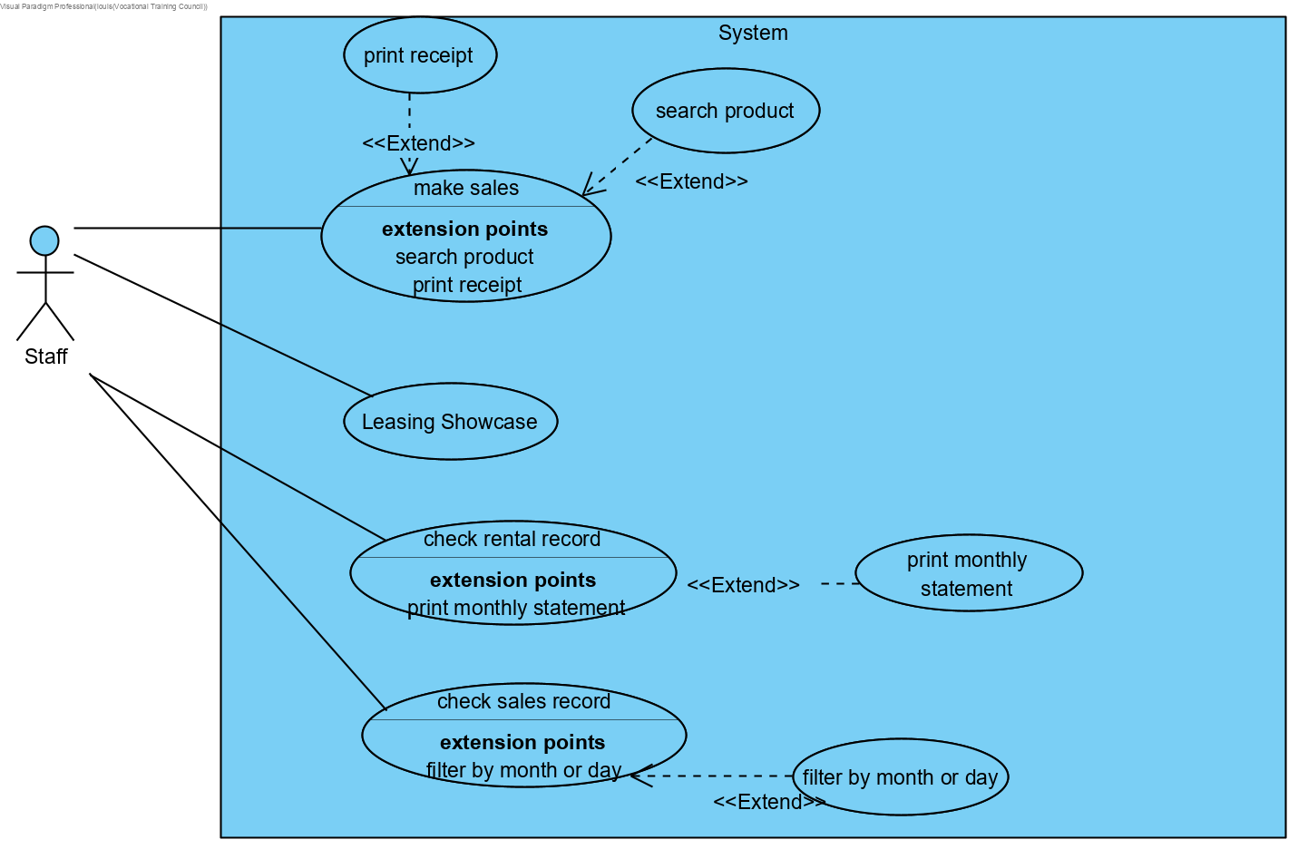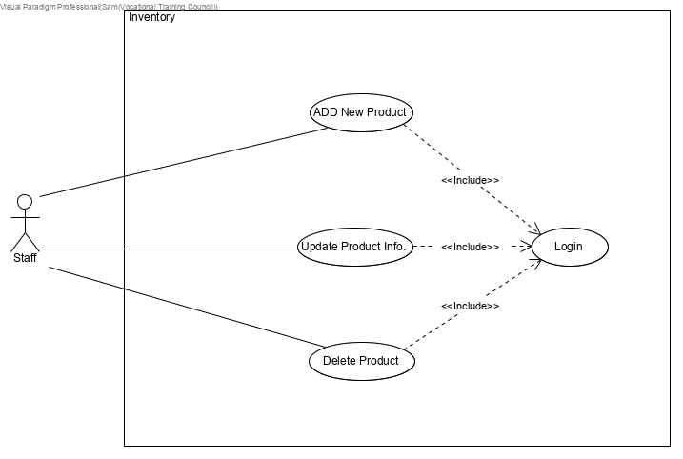

#### Class Diagram(Design Level)

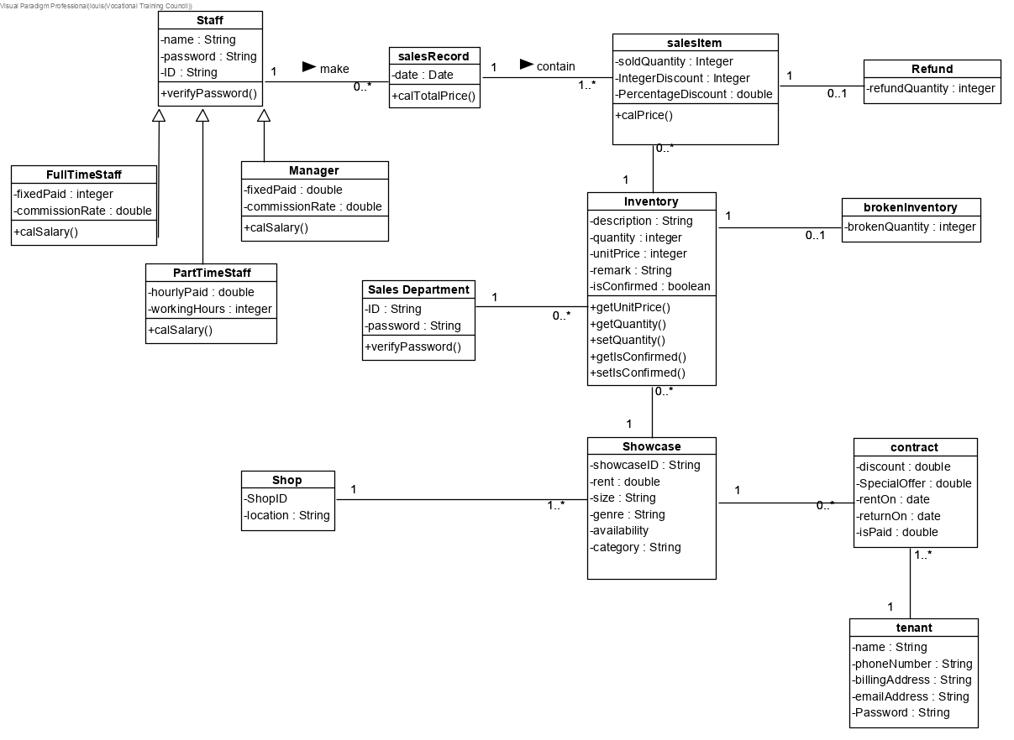

#### Sequence Diagram (System Level) & Use Case Description

##### Login

|  |  |
| --- | --- |
| Use Case Name | Validate user |
| Use Case ID | UC-001 |
| Actors | Staff, tenant, manager |
| Description | Validate the identity of a user by verifying the username and password |
| Pre-condition |  |
| Post-condition |  |
| Basic flow | 1. The user enter an account and a password. 2. The user press the <Enter> to commit the entry 3. The system verify the account and password. 4. If the password is valid, the system acknowledges the entry. |
| Exception flow | The user enters an invalid password, the use case restarts. |

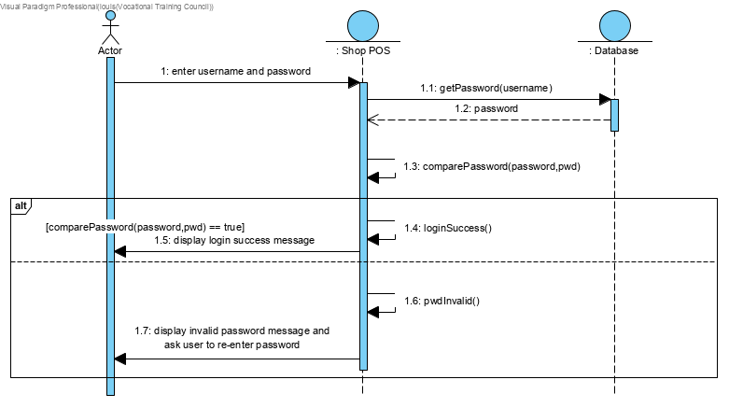

##### Inventory Sales System

|  |  |
| --- | --- |
| Use Case Name | make sales |
| Use Case ID | ISS-001 |
| Actors | Staff |
| Description | Staff makes a sales and insert a sales record into database. |
| Pre-condition | User's identity has been authenticated |
| Post-condition | A sales record is inserted into database. |
| Basic flow | 1. Invoke use case "Validate user" UC-001. 2. The staff can make sales and create an invoice. 3. The system displays all inventories in the shop. 4. The staff enter the showcase ID for filtering. 5. The staff select and add a inventory as a sales item in the invoice. 6. The staff enter the quantity of the sales item. 7. The staff enter the discount(if any). 8. The system calculate the amount. 9. The staff receive the payment. 10. The staff check out all sales items in the sales list. 11. The staff can print out the sales record to customer. |
| Exception flow | Step 4-7 can be repeated until the staff proceeds to step 7. |

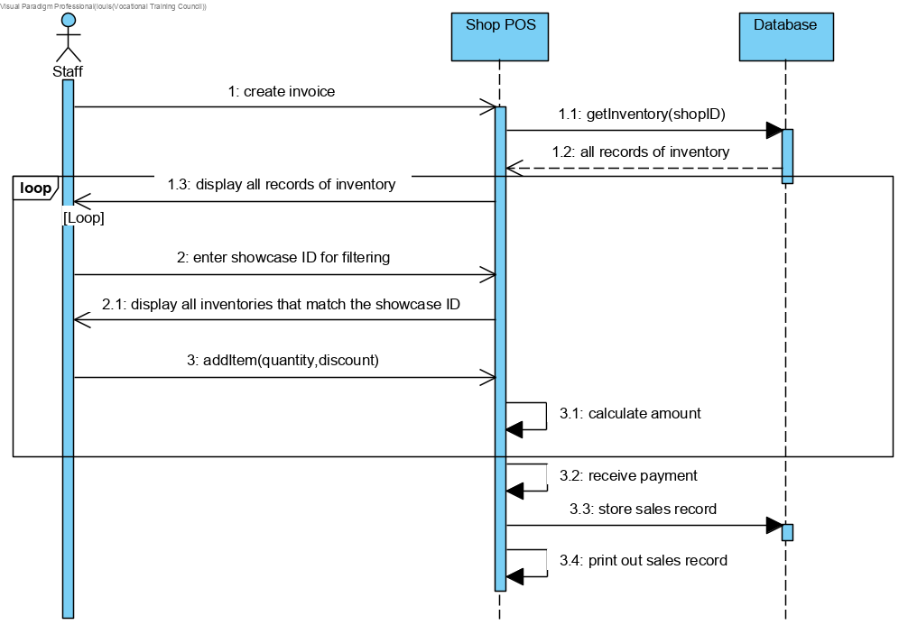

|  |  |
| --- | --- |
| Use Case Name | handle refund |
| Use Case ID | ISS-002 |
| Actors | Staff |
| Description | Customer ask for a refund. Staff insert a record of refund into database. |
| Pre-condition | User's identity has been authenticated.  Customer take items and receipt back to the store and ask for refund. |
| Post-condition | a record of refund is inserted into database |
| Basic flow | 1. Staff check the item is not damaged. 2. Staff create a refund list. 3. System display all sales record. 4. Staff enter the sales record ID for searching. 5. System display all sales items in the sales record 6. Staff select and add a sales item as a refund item to the refund list. 7. The staff enter the quantity of the refund item. 8. The system calculate the amount of refund. 9. The staff take the refund item from customer and give the amount of refund to customer. 10. The staff save the record of refund. |
| Exception flow |  |

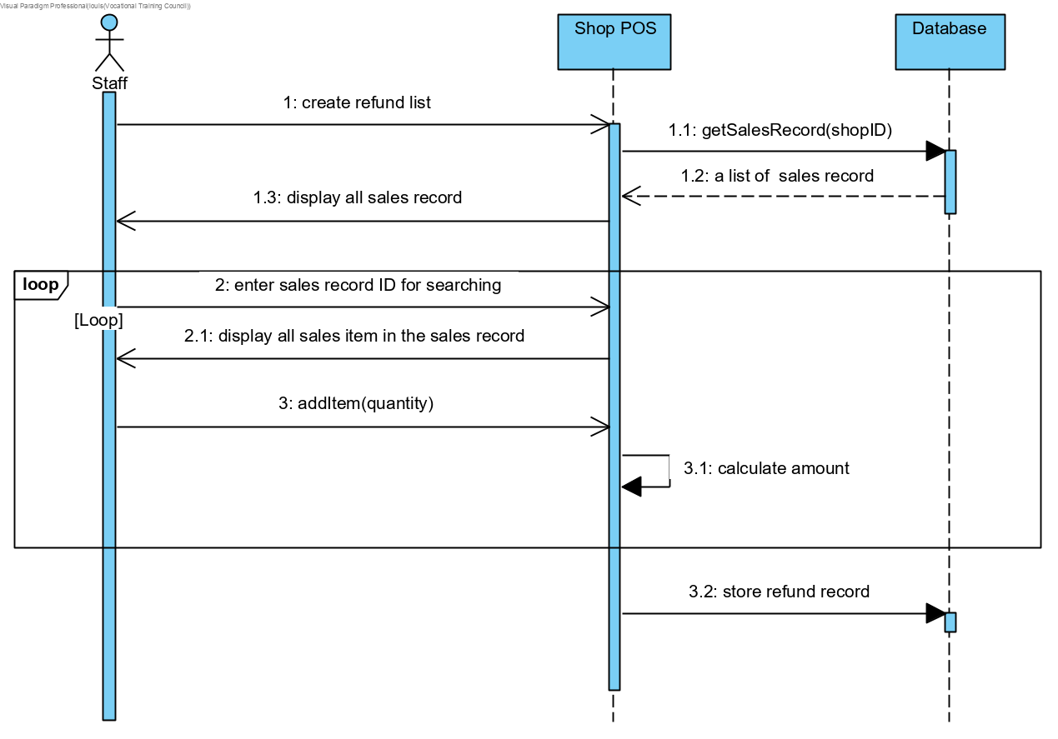

|  |  |
| --- | --- |
| Use Case Name | Print out sales record |
| Use Case ID | ISS-003 |
| Actors | Staff |
| Description | Staff print out a sales record. |
| Pre-condition | User's identity has been authenticated. |
| Post-condition | A sales record is printed out. |
| Basic flow | 1. Staff view all sales records from database. 2. Staff enter the Staff ID and sales date for filtering. 3. System displays the sales records that match the condition. 4. Staff select a sales record to print it out. |
| Exception flow |  |

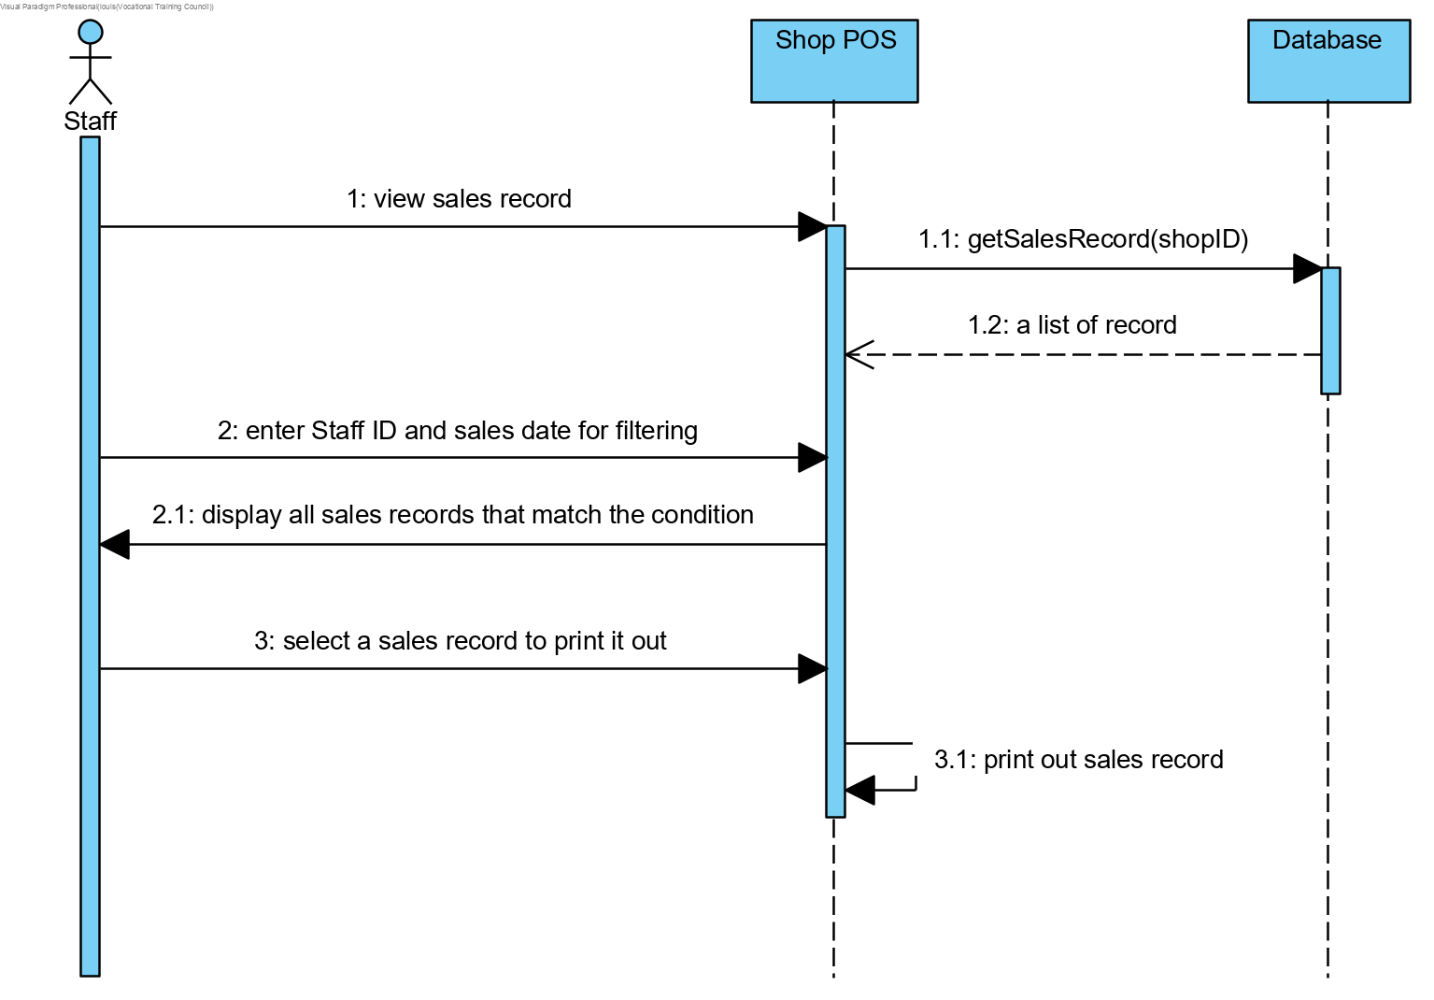

|  |  |
| --- | --- |
| Use Case Name | View sales record |
| Use Case ID | ISS-004 |
| Actors | Tenant |
| Description | Tenant can view his sales record through the application |
| Pre-condition | User's identity has been authenticated. |
| Post-condition |  |
| Basic flow | 1. Tenant view all sales records related to his showcase from database. 2. Tenant can filter the sales record by store ID or sales date. 3. System displays the sales records that match the condition. |
| Exception flow |  |

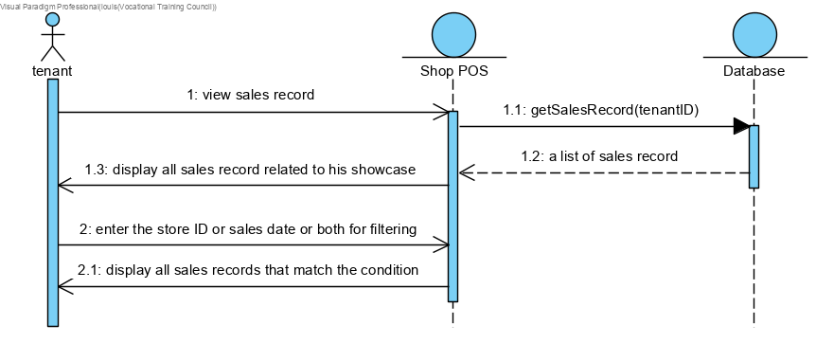

##### Inventory Management System

|  |  |
| --- | --- |
| Use Case Name | Pre-input inventory |
| Use Case ID | IMS-001 |
| Primary Actor | Tenant |
| Secondary Actor(s) |  |
| Brief Description | Tenant provides item name, category of item, amount of item and item image to inventory system. |
| Preconditions |  |
| Flow of Events | 1. Select showcase want to input. 2. Tenant enter item name, category of item, amount of item, Item price and upload item image. 3. The system creates pre-input record and send to branch. |
| Post-conditions | A pre-input record is created |
| Alternative flows and exceptions |  |
| Non-behavior requirements |  |

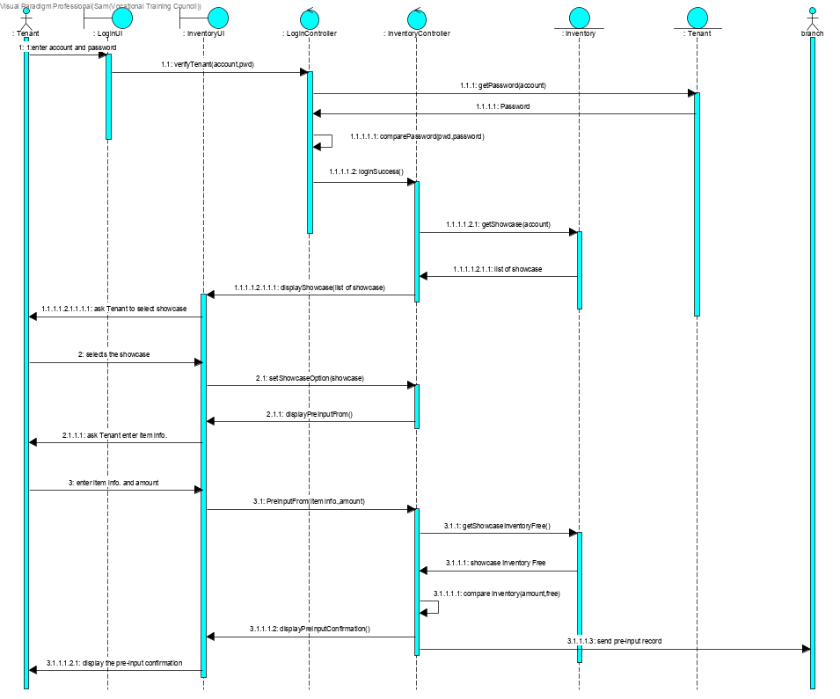

|  |  |
| --- | --- |
| Use Case Name | Input inventory in tenant showcase |
| Use Case ID | IMS-002 |
| Primary Actor | Staff |
| Secondary Actor(s) | Manager |
| Brief Description | staff insert a record of the new inventory to a tenant showcase. |
| Preconditions |  |
| Flow of Events | 1. The staff enter item name, category of item, amount of item and Item price. 2. The system creates a new inventory of a tenant showcase. |
| Post-conditions |  |
| Alternative flows and exceptions |  |
| Non-behavior requirements |  |

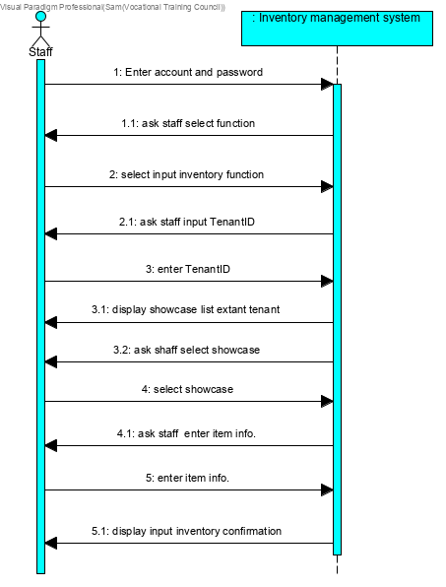

|  |  |
| --- | --- |
| Use Case Name | Confirm pre-input |
| Use Case ID | IMS-003 |
| Primary Actor | Staff |
| Secondary Actor(s) | Manager |
| Brief Description | staff confirm the amount of pre-input item when tenant take pre-input item to shop. |
| Preconditions | Tenant finished IMS-001 |
| Flow of Events | 1. Staff confirms amount is the same as the pre-input record. 2. The system changes the pre-inventory to new inventory. |
| Post-conditions | The system creates new inventory |
| Alternative flows and exceptions |  |
| Non-behavior requirements |  |

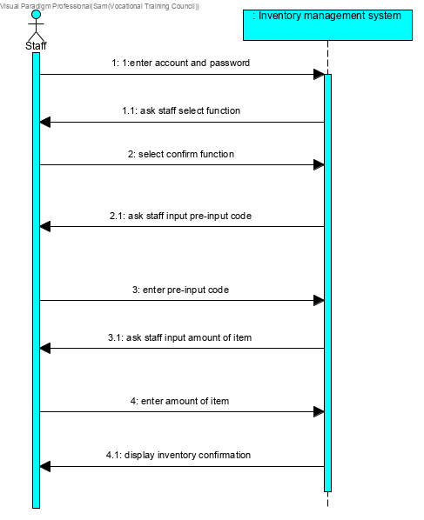

|  |  |
| --- | --- |
| Use Case Name | Delete inventory |
| Use Case ID | IMS-004 |
| Primary Actor | Manager |
| Secondary Actor(s) |  |
| Brief Description | Manager will delete inventory when tenant leaseback showcase. |
| Preconditions | Have showcase |
| Flow of Events | 1. Select the showcase 2. Confirm to delete. 3. The system deletes the inventory. |
| Post-conditions | The system will delete inventory record |
| Alternative flows and exceptions |  |
| Non-behavior requirements |  |

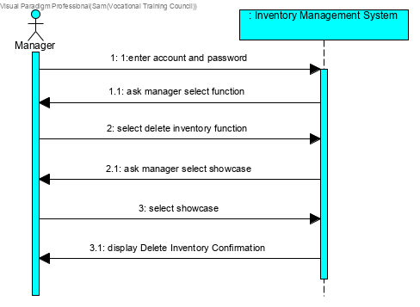

|  |  |
| --- | --- |
| Use Case Name | Change quantity of inventory |
| Use Case ID | IMS-005 |
| Primary Actor | Manager |
| Secondary Actor(s) |  |
| Brief Description | Manager can change quantity of inventory when item is broken. |
| Preconditions | Have inventory |
| Flow of Events | 1. Select the showcase 2. Enter amount of broken item. 3. The system update amount of inventory. |
| Post-conditions |  |
| Alternative flows and exceptions |  |
| Non-behavior requirements |  |

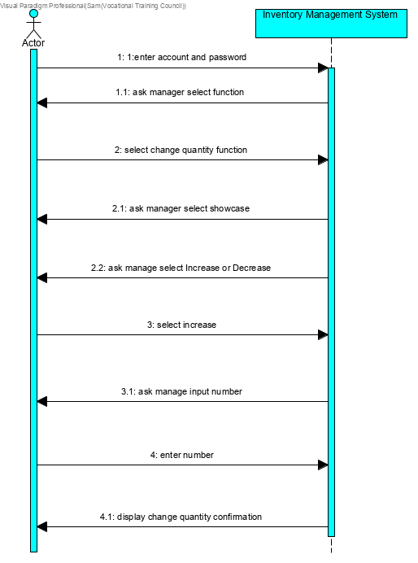

|  |  |
| --- | --- |
| Use Case Name | Input inventory in the private showcase |
| Use Case ID | IMS-006 |
| Primary Actor | Sales department |
| Secondary Actor(s) |  |
| Brief Description | Sales department will Input inventory in the private showcase when showcase have not rent out. |
| Preconditions | Showcase is private showcase |
| Flow of Events | 1. Select private showcase 2. Enter amount of item 3. The system creates new inventory or update inventory. |
| Post-conditions | The system creates new inventory or update inventory |
| Alternative flows and exceptions |  |
| Non-behavior requirements |  |

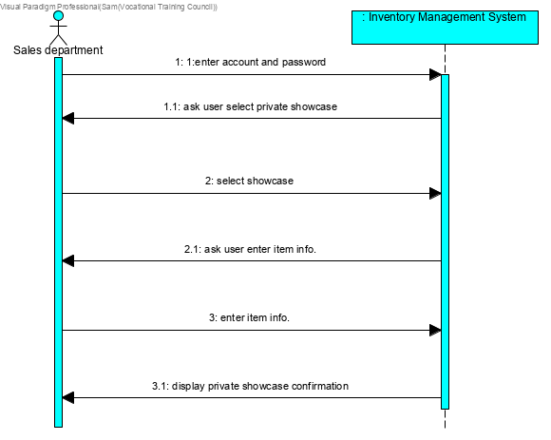

##### Showcase leasing System

|  |  |
| --- | --- |
| Use Case Name | Check discount condition |
| Use Case ID | SLS-001 |
| Actors | Staff, Manager, Sales department |
| Description | Actors check the condition of offering a discount. |
| Pre-condition | A user has a valid account. |
| Post-condition | Print out tenant name, showcase size, total offer, discount, contract |
| Basic flow | 1. Include UC-001 “Login” 2. The user select check discount condition. 3. System displays the detailed information of discount |
| Exception flow | The user enters an invalid TenantID, the use case jump to step 2. |

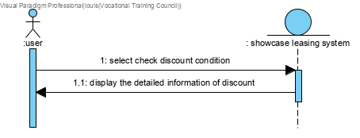

|  |  |
| --- | --- |
| Use Case Name | Edit the condition |
| Use Case ID | SLS-002 |
| Actors | Manager, Sales department |
| Description | Actors change the condition of the discount or the percentage of the discount. |
| Pre-condition | A user has a valid account. |
| Post-condition | Discount has been changed. |
| Basic flow | 1. Include UC-002 “Check discount condition” 2. The user select edit the condition. 3. The system ask the condition. 4. The user input the condition. 5. The system change the discount and display success massage. |
| Exception flow |  |

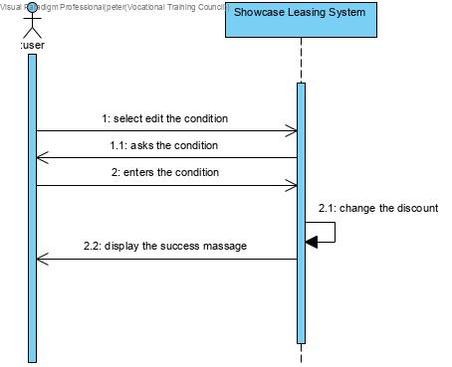

|  |  |
| --- | --- |
| Use Case Name | Make a renting contract |
| Use Case ID | SLS-003 |
| Actors | Staff, Manager, Sales department |
| Description | prepare a renting contract. |
| Pre-condition | A user has a valid account. |
| Post-condition | Print out a contract |
| Basic flow | 1. Include UC-001 “Login” 2. The user select make a renting contract. 3. The system ask tenantID, started date, period of renting, given discount. 4. The user input tenantID, started date, period of renting, given discount. 5. The system ask is it special offer. 6. If the user select “yes”. 7. The system ask the special offer. 8. The user input special offer. 9. The system sand the contract to server and print finish message. |
| Exception flow | Step 6 if user select “no” ,jump to step 9. |

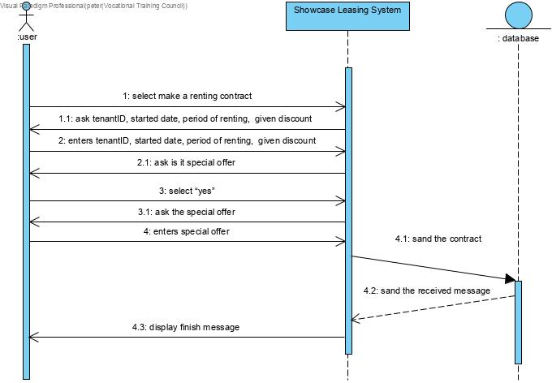

|  |  |
| --- | --- |
| Use Case Name | Confirm contract is paid |
| Use Case ID | SLS-004 |
| Actors | Staff, Manager, Sales department |
| Description | Actors change the "isPaid" attribute in the contract. |
| Pre-condition | A user has a valid account. |
| Post-condition | contract attribute has been changed. |
| Basic flow | 1. Include UC-002 “Check discount condition”. 2. The user select contract. 3. The system show the contract situation. 4. If the user set “isPaid” to true. 5. The system ask user to confirm the setting. 6. The user confirm. 7. The system set “isPaid” to true and print finish message. |
| Exception flow | Step 9 if user set “isPaid” to false ,step 12 system set “isPaid” to false |

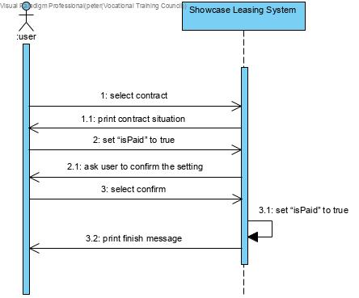

|  |  |
| --- | --- |
| Use Case Name | Suggest earliest available showcase to tenants |
| Use Case ID | SLS-005 |
| Actors | Staff, Manager, Sales department |
| Description | staff can search and suggest the earliest available showcase to tenants through the system. |
| Pre-condition | A user has a valid account. |
| Post-condition | System displays all contracts sorted by the due date and grouped by showcaseID. |
| Basic flow | 1. User enters shopID 2. System displays all contracts in that shop 3. User sort contracts by due date and group them by showcase ID |
| Exception flow |  |

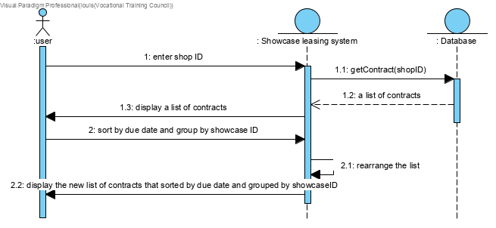

##### Showcase Management System

|  |  |
| --- | --- |
| Use Case Name | View showcase information |
| Use Case ID | SMS-001 |
| Actors | Staff |
| Description | Staff view showcase information which can be filtered by store ID, the availability and sorted by the price. |
| Pre-condition | User's identity has been authenticated |
| Post-condition |  |
| Basic flow | 1. Invoke login 2. Staff is going to view information. 3. System displays a list of showcases, 4. Staff filter the list by entering the store ID. 5. Staff filter the list by selecting the availability. 6. Staff sort the list by price. |
| Exception flow | If the store ID entered by staff is incorrect, system asks staff to re-enter. |

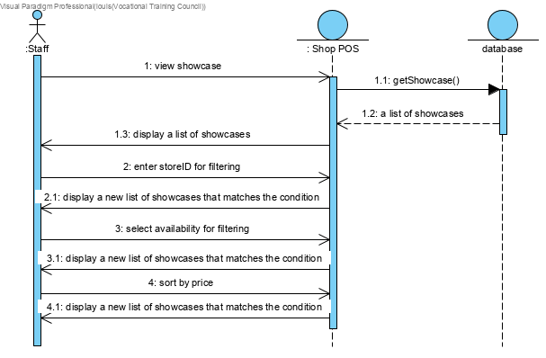

|  |  |
| --- | --- |
| Use Case Name | Edit showcase information |
| Use Case ID | SMS-002 |
| Actors | Manager |
| Description | Manager can edit the price or genre of showcase. |
| Pre-condition | User's identity has been authenticated |
| Post-condition |  |
| Basic flow | 1. Invoke login 2. Invoke view showcase information SMS-001 3. Select a showcase 4. Enter the new price 5. select a genre 6. System update the record of showcase in the database. |
| Exception flow | If the store ID entered by staff is incorrect, system asks staff to re-enter. |

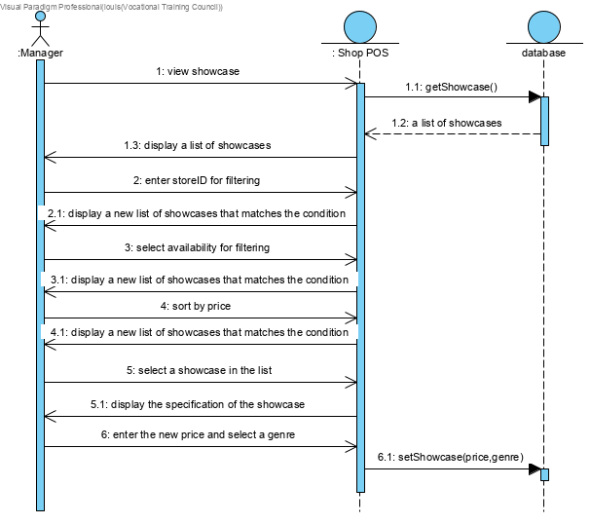

#### Entity Relationship Diagram

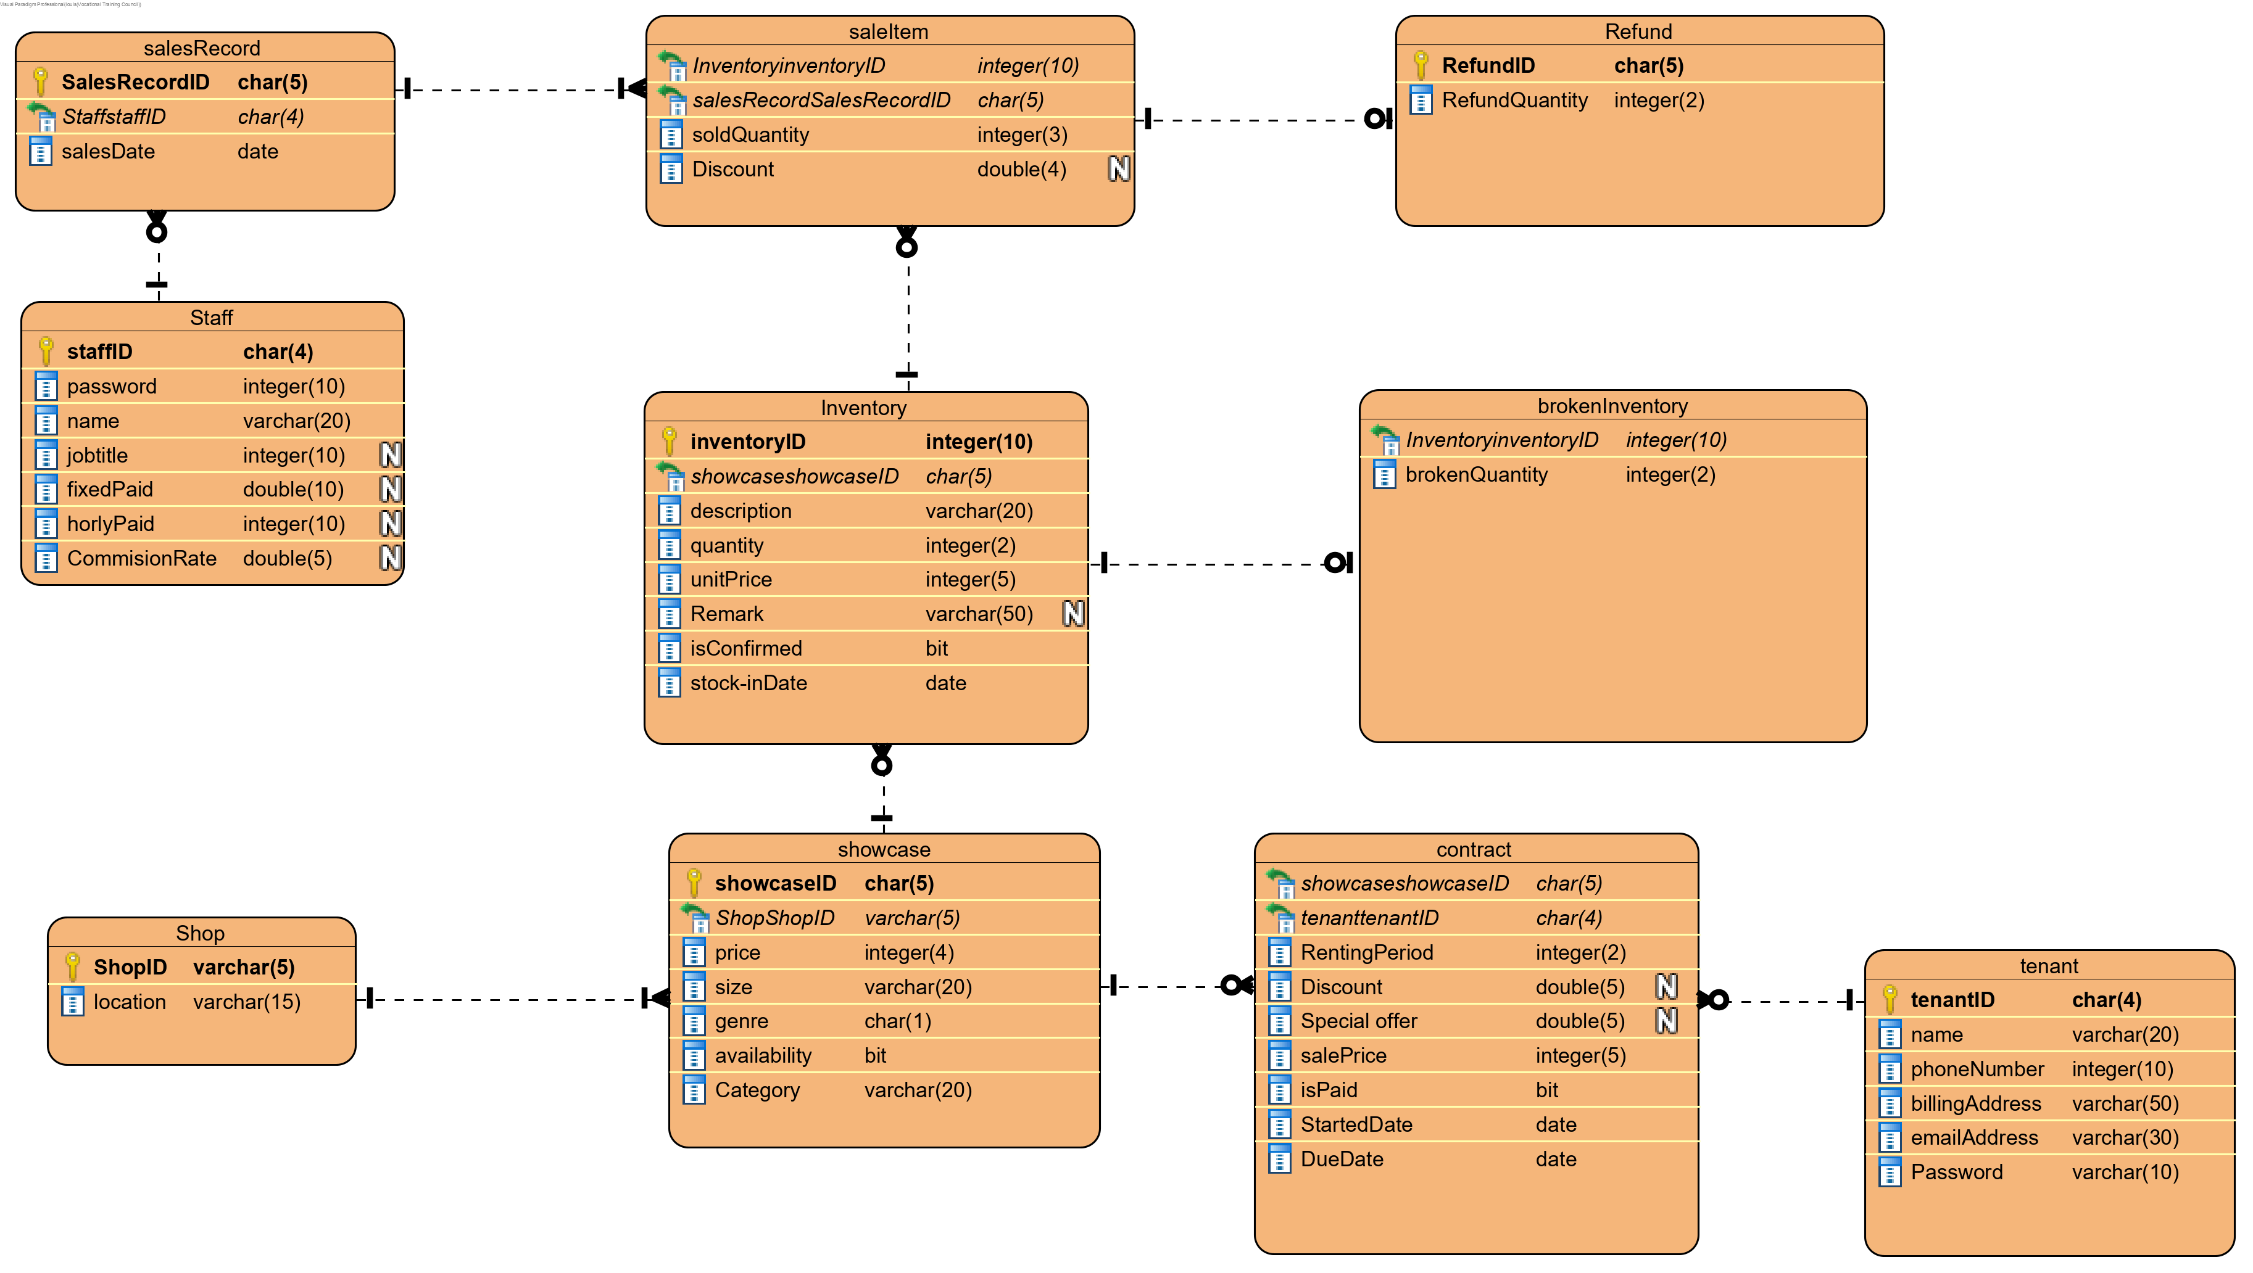

# User Interface and Report Design

Login

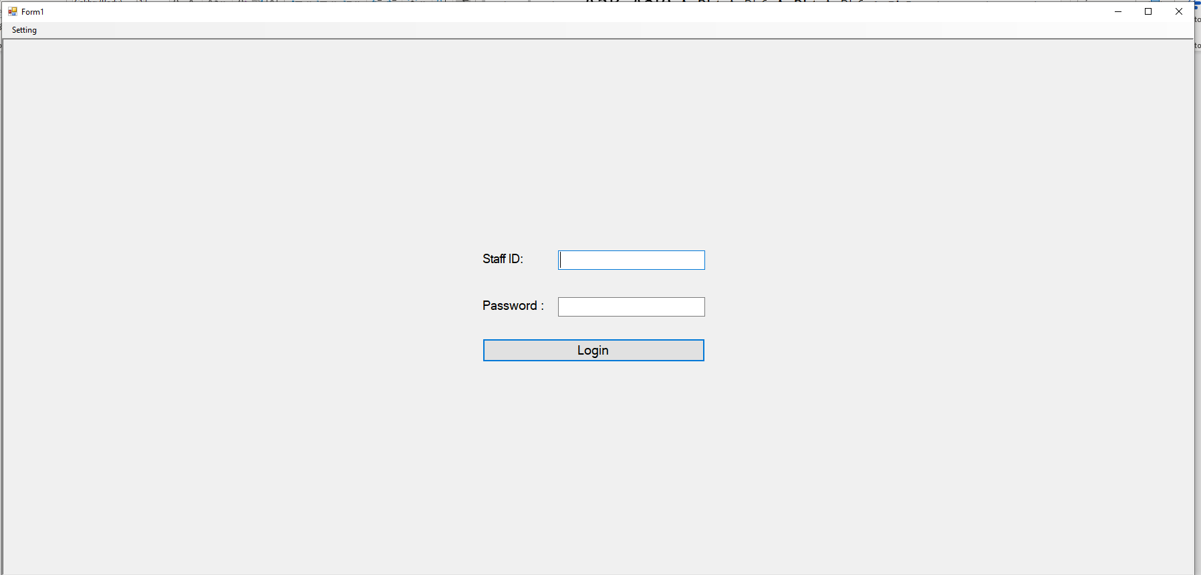

ShowcaseRental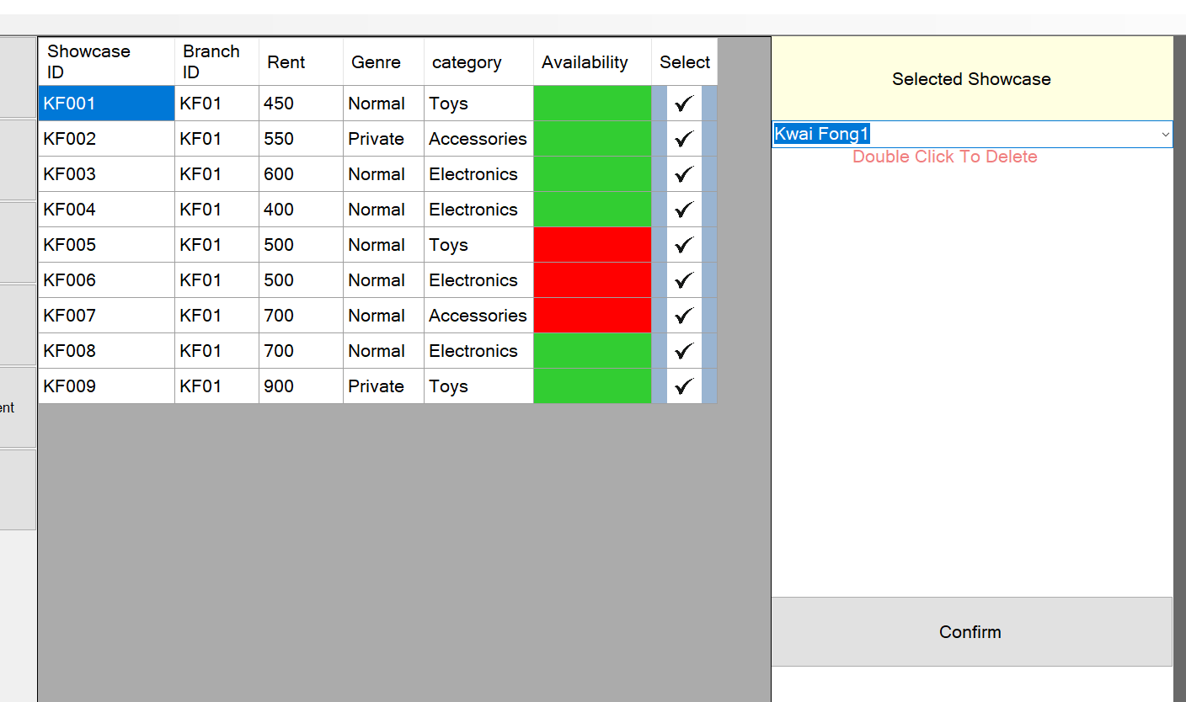

Rental Record

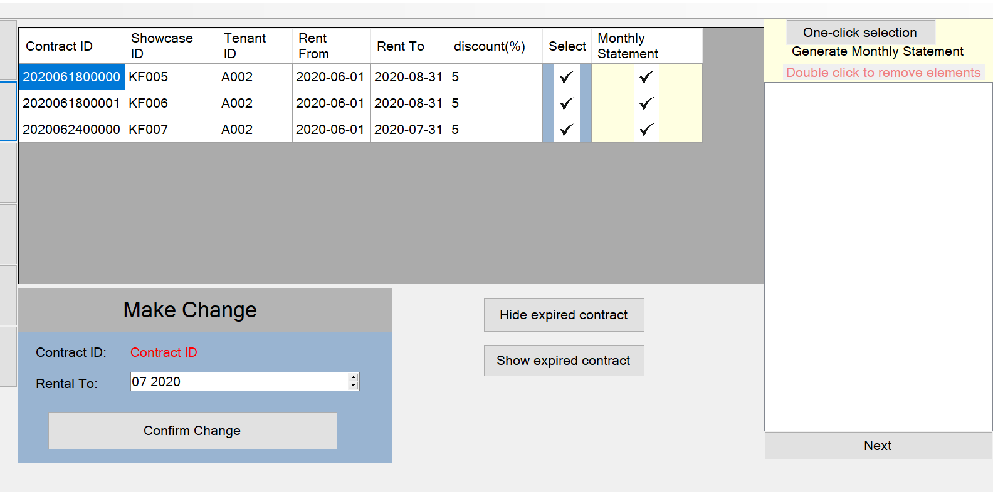

Customer Sales Management

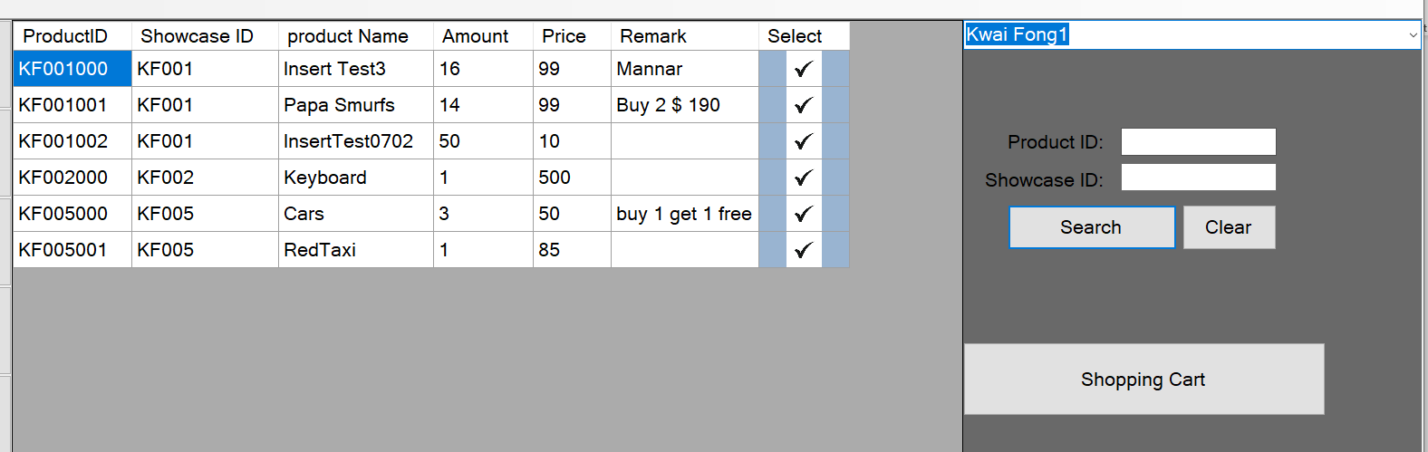

Sales Record

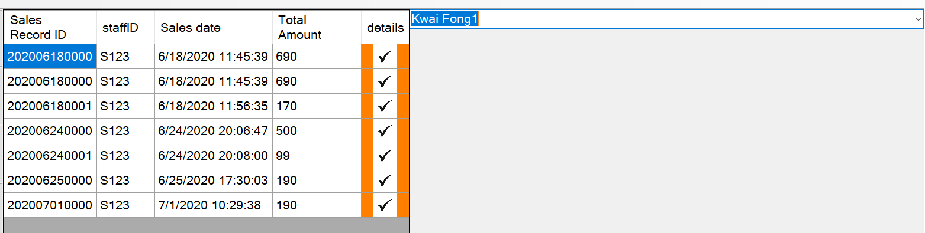

# Test plan

1. Rent Showcase
2. Generate Monthly Statement
3. Make change of showcase rental record
4. Shopping
5. View Sales Record

# Project Schedule

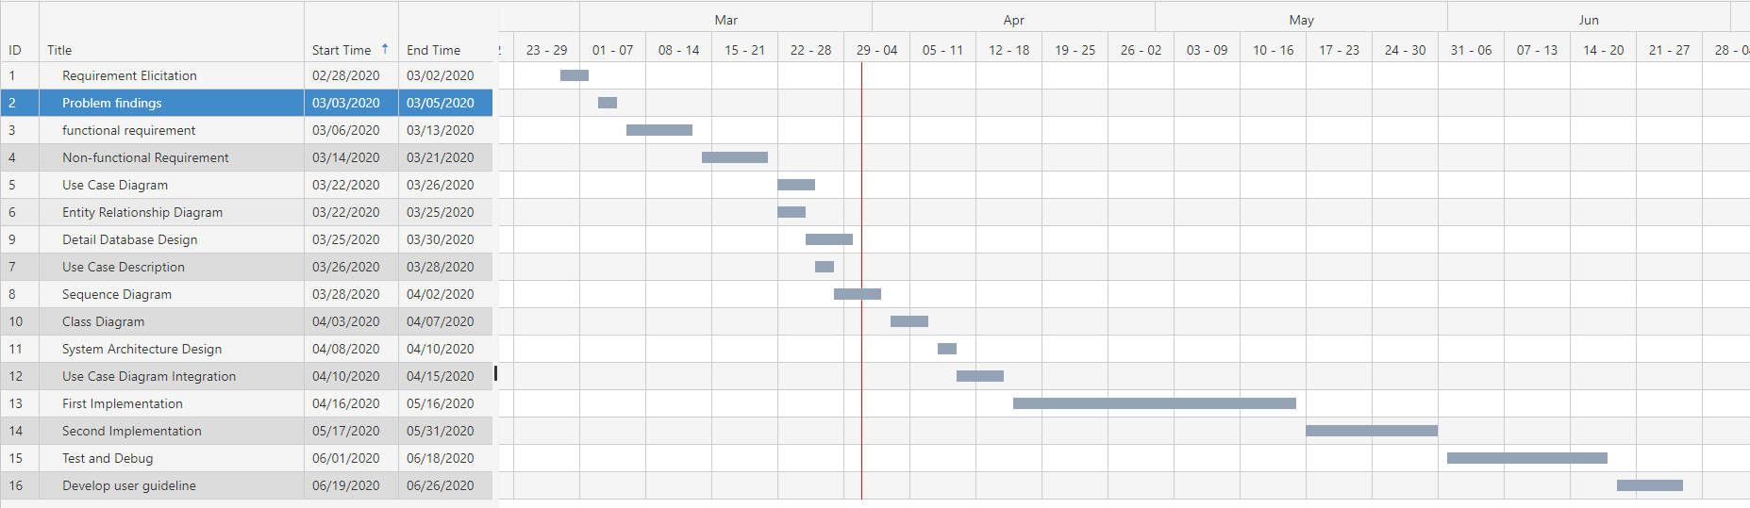

# Conclusion

After a detailed analysis and design, we have refined functional requirement. Also the use case diagram we have designed to simulate the interaction between the user and the system. The entity relationship diagram shows that how does the information associated with each other. The sequence diagram shows the messages exchange internally in the system. Now, we can move on to the next stage and conduct the first implementation.

# Project Log

|  |  |
| --- | --- |
| Date | Description |
| 27-Feb | Project starts |
| 2-Mar | Requirement Elicitation (Finished) |
| 13-Mar | Functional Requirement Design (Finished) |
| 21-Mar | Non-Function Requirement Design (Finished) |
| 26-Mar | Use Case Diagram Design (Finished) |
| 25-Mar | Entity Relationship Diagram Design (Finished) |
| 30-Mar | Detailed Database Design (Finished) |
| 28-Mar | Use case description (finished) |
| 2-Apr | Sequence Diagram (Finished) |
| 7-Apr | Class Diagram (Finished) |
| 10-Apr | System Architecture Design (Finished) |
| 15-Apr | Use Case Diagram Integration (Finished) |
| 16-May | First Implementation (Finished) |
| 31-May | Second Implementation (Finished) |
| 18-Jun | Test and Debug (Finished) |
| 26-Jun | User Guideline Development(Finished) |